Elizabeth Barrett
HIST420
Prof. Michelle LeMaster
Research Paper
11/27/2022

HOLY SMOKE: TOBACCO IN THE EARLY MODERN ATLANTIC WORLD

I’m so tired, I’m feeling so upset
Although I’m so tired, I’ll have another cigarette
And curse Sir Walter Raleigh
He was such a stupid git

- “I’m So Tired” (21-26) on The Beatles

Tobacco was central to the development of the early modern Atlantic world. Adapted from the medicinal, spiritual, and diplomatic practices of indigenous American peoples, the plant cropped up in the sixteenth century European market as a medicinal herb before subsequently arising as a recreational, luxury commodity. The lyrics above, written by John Lennon in 1968 while attending a transcendental meditation camp in India, speak to the longevity of tobacco’s popularity and use, as well as hint to a few disappointing attributes of its longer-term use. Once ignited, the psychoactive qualities of the leaf evoke a heady sensation, making the experience enlightening, akin to a bright reflection of the Promethean spark that allegorically represents man’s elevated mental capacity over all other species. However, after years of concentrated, habitual use, it is the opposite that occurs in the body, the alkaloid in the plant only capable of feeding the craving rather than imbuing the smoker with that initial body-mind illumination of that initial inhale. Furthermore, in invoking curses against Sir Walter Ralegh, Lennon popularizes the false notion that it was the explorer who introduced Nicotiana rustica to the market, thus revealing further misunderstandings of the early modern proliferation of tobacco. This essay, following these examples of how tobacco has left an indelible impression, will follow the trail of sixteenth and seventeenth century European reactions to tobacco in literature, including its use as a medicine, commodity, and later recreational drug eventually best enjoyed as a vector for social stamina and enlightened discourse.
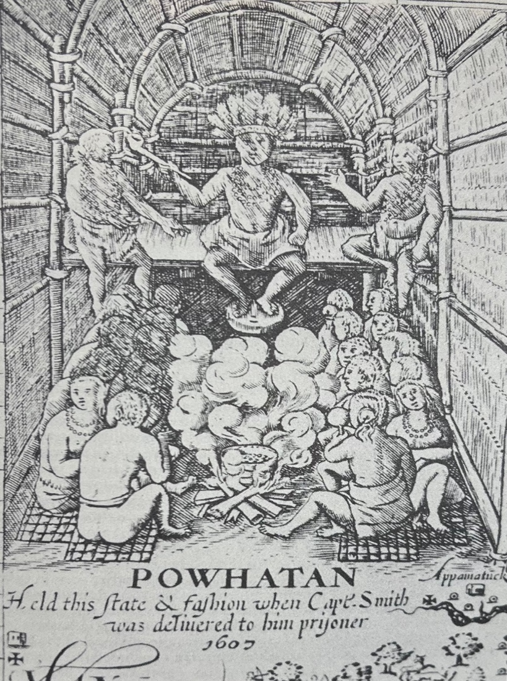
Figure 1: Detail from Captain John Smith’s map depiction Powhatan smoking a pipe while presiding over his court. Image from Helen C. Rountree, The Powhatan Indians of Virginia: Their Traditional Culture, (Norman: University of Oklahoma Press, 1989), 107.
The reasons for tobacco’s popularity are manifold: nicotine, the alkaloid resident in tobacco, can provide an immediate rush to the nervous system, igniting excitement or delight in the body and only later suppressing its systems. As far as plant alkaloids go it is also highly addictive, and in large doses, or in habitual practice, carries only the depressive affect. This means once hooked, the elation companionate with its initial use may not quite return, and this phenomenon of diminishing benefits is even more intriguing when considered in tandem with a deeper psychological impulse present in the early modern European mindset, one of “unrequitedness,” or, an unreachable ideal. As this mental effect of long-term addiction to medicines was fed by the nicotine, especially in conjunction with the inability to achieve the same early euphoria, this affect may have played no small part in the subsequent late-sixteenth and seventeenth century popularization of tobacco. Seen another way, even if a seventeenth century tobacco user wished to cease smoking because they no longer experienced that preliminary elation, due to those addictive properties of nicotine, they were probably inextricably tethered to it. Worse, to the human body and its organs, long-term unchecked use may also spell disaster.
These attributes were not necessarily evident in the initial accountings of contact between European and Indians with tobacco. Christopher Columbus first describes tobacco as a “half-burnt weed,” one that the Indians were “accustomed to smoke.” Subsequently, it proliferated into the European marketplace alongside the mineral wealth already pouring in from Spanish imperial colonies. The Spanish, taking their cues from how Indians used the plant, flooded European markets with the leaf as both a medicine and a recreational item, especially used in feasting and diplomatic events. As an import, an exotic materia medica, and a luxury item, these characteristics coalesced to offer the European public a novel status-affirming commodity, one which might be used in a multitude of applications in order to display wealth or power, heal, imbibe, or even ascend metaphysically through spiritual use.
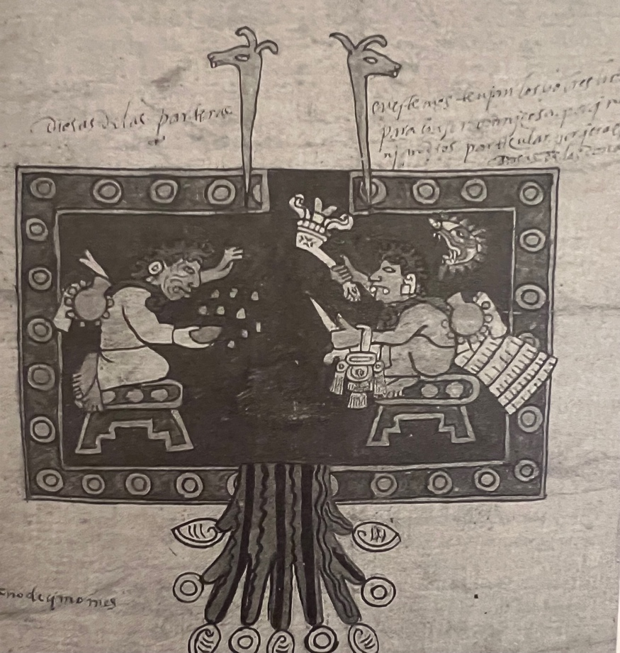
Figure 2: Detail from the Codex Borbonicus, fol. 21. Depiction of central Mexican primordial man and woman wearing tobacco gourds and possibly using tobacco powder in their celebration of creation. From Norton, Sacred Gifts, Profane, Pleasures, 39.
Early modern Europeans’ search for materia medica, or even a universal panacea, formed no small part of the exploration of the Atlantic. That Europeans were on the hunt for more medicines is sometimes marginalized in favor of the vast mineral wealth that flooded the market during the sixteenth and seventeenth centuries and had wide-ranging impact. In recent decades, scholars have targeted the impact of more passive modes of exchange between hemispheres, such as germs and disease. Taking that further, the technological imbalances brought by colonization projects especially when compounded by the genocidal forces of disease have also come under scrutiny. However, scholars have also signaled an early modern trade in drugs and medicines as equally imperative to their hunger for spices, gold, silver, and the labor to extract these resources. Marcy Norton, in particular, points to the stripping of cultural content from Indian goods as one reason for tobacco’s relative obscurity in the general histories of the Atlantic. The flexibility of tobacco and the mutability of its uses, therefore, underscore the cloudiness of its European uptake, the methods through which English dominance of this commodity emerged in the seventeenth century, and even the academic discourses that currently inform scholarship.
Spanish and English explorers were not the only Europeans to come into contact with tobacco. In 1535, the Frenchman Jacques Cartier encountered it on his Second Voyage to North America. As later translated by Richard Hakluyt, Cartier explained: “We ourselues haue tried the same smoke, and hauing put it in our mouthes, it seemed almost as hot as Pepper.” Notwithstanding this intense experience, subsequent descriptions would supersede Cartier’s poor opinion. In 1554, Flemish herbalist Rembert Dodoens (1517-1585) published a depiction of the plant in his Cruydeboeck mistakenly identifying it as Hyocyamus luteus, or yellow henbane, rather than Nicotiana rustica. Anne Charleton posits this confusion may have stemmed from tobacco’s hallucinogenic affect, an aspect also prevalent in the former herb. Thus, the active properties as demonstrated through accounts and experimentation can be seen to impact both the cataloging of the plant and scientific understanding of its function in the body.
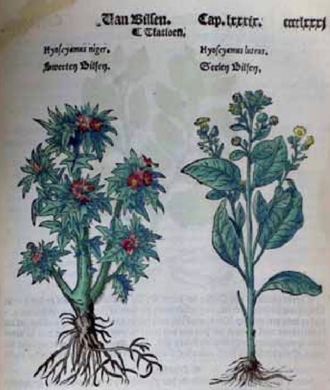
Figure 3: Page from Rembert Dodoens Cruydeboek, 1554, mistakenly labelling tobacco as “Yellow Henbane.” From Robrecht Van Hee, “Dawn and Decline of the Holy Smoke,” Acta Chirurgica Belgica 108 (2008), 274.
By the 1560s, tobacco was more fully introduced and popularized as a medicine throughout Europe by Jean Nicot de Villemain, French ambassador to Lisbon. While visiting a prison, he obtained a tobacco plant of Floridian provenance, and soon thereafter found that it flourished in his Iberian garden. When one of Nicot’s retainers presented with a cancer on his face, Nicot applied cured and pulverized leaves along with juice of the plant to treat the wound. Reputedly, the cure was successful. Consequently, Nicot graciously distributed the herb around the French court to the extent that it became known as nicotiane, eponymously and thereafter linking tobacco’s alkaloid with the ambassador. It should be noted, however, that Nicot’s panacea was utilized solely as a topical plaster, rather than as the smokable herb.
By 1569, Nicolás Monardes, a doctor from Seville, published a popular tract that included a description of the many benefits of tobacco to the human body, focusing upon its myriad medicinal aspects. Six years later, John Frampton translated this work into English and alluringly dubbed the tome Joyfull Newes out of the Newfound World, hinting at the expected wide-ranging medicinal effects, allowing the English to anticipate the arrival of that panacea. Monardes’ contribution to the popularity of tobacco use in Europe cannot be underestimated; using Galenic four humors, he posited that the use of the plant’s dry and warm properties would counteract all illnesses considered to be cold and wet. Furthermore, Monardes advocates for tobacco use as a stimulant: it could reduce weariness, stave off hunger, rouse fatigued workers, and assisted in relaxation.
Therefore, the many health and social benefits are seen to infiltrate into the transatlantic marketplace. The fascination with tobacco as a panacea, as well as the flexibility of its function was cataloged and proven through medical treatises. Along with chocolate and coffee, by the late sixteenth century the demand for tobacco exceeded its availability in Europe. Sir Walter Ralegh’s identification of the herb as an effective foundational crop upon which to build the English colonization project therefore emerged in response to the dominance of Spanish traders. When understood in the context of the religious and geopolitical conflicts between Protestant England and Catholic Spain, extracting the plant for themselves rather than reliance on black markets was indeed a better way forward. By 1590, Ralegh’s indirect popularization of tobacco is well displayed in these lines from Edmund Spenser’s The Faerie Queene:
Into the woods thenceforth in hast she went,
To seeke for hearbes, that mote him remedy;
For she of hearbes had great intendiment,
Taught of the Nymphe, which from her infancy
Her nourced had in trew Nobility:
There, whether it diuine Tobacco were,
Or Panachœa, or Polygony,
She found, and brought it to her patient deare
Who al this while lay bleeding out his hart-bloud near.

This excerpt revolves around characters who symbolically represent both Queen Elizabeth I and Ralegh, coincidentally mark the plant’s first appearance in English poetry.
By the time John Gerard’s (1545-1612) Herball was published in London in 1597, the many perceived uses of tobacco as a medicine were evident to European consumers. Gerard affirms Monardes’ Galenic-based assertions that “it is hot and dry…in the second degree,” and it has the power “to cleanse away filthy humors.” He also states that its virtues include the ability to remedy “paine in the head called Megram,” for a cold stomach, against pain in the kidneys, for “fits of the Mother,” pains brought about by gout, toothache, worms, scabby skin, dropsy, agues, colic, wind, hemorrhoids, sciatica, and as a prepared drink, an emetic against poisons. Though Gerard warns against smoking the herb too often, he does observe that it functions well when administered topically, or as an ointment.
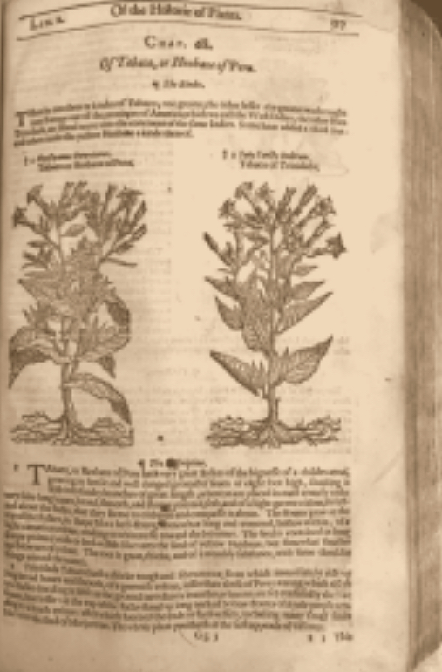
Figure 4: Tobacco page from John Gerard’s 1597 The Herball Or Generall Historie of Plantes.

Yet one London physician authoritatively labels tobacco as that elusive panacea. In 1597, Giles Everard first published his Panacea; or the universal medicine, being a discovery of the wonderfull vertues of tobacco in Latin, later translated and republished in the vernacular in 1659. In it, he describes the history of tobacco as is known to him, and then goes further to weave its properties in with the known medicinal philosophies and discourses surrounding lauded ancients like Pliny, Hippocrates, and Democritus, imbuing it further with European bona fides. Everard does, however, address the suspect nature of the plant as derived from aspects of ritual and religious American Indian use, and spins the narrative in such a way that it is a net positive to have been found among the indigenous:
the providence God intended by discovering this herb to Christians amongst the Indians, that by their daily commerce, the Gospel of Jesus Christ should be made know to those Heathen people, who sit in darkness and the shadow of death.

Thus, this points to an intentional divine positioning of tobacco in the Americas specifically as a lure for the missionizing Europeans to convert the Indians to Christianity.
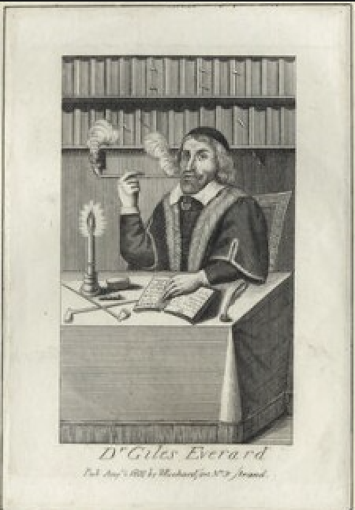
Figure 5: Line engraving of Dr. Giles Everard, after Unknown artist, published by William Richardson in 1800. From the National Portrait Gallery.
But as a smokable, recreational herb, tobacco captivated the public. Despite its medicinal and spiritual affects, Everard also claims it is critical to the economy, “For were the planting and traffick of Tobacco now hindred, millions of the Nation, in all probability must perish for want of food, their whole livelihood almost depending upon it.” Considering Everard’s publication was written before England’s participation in mass growing of tobacco during the colonization of the Chesapeake, it is indeed astounding that so quickly the commodity would become entrenched in the trades of so many English people. This widespread use and dependence upon tobacco was bound to provoke detractors. In 1602, Work for Chimny-Sweepers, Or, A Warning for Tabacconists Describing the Pernicious Vse of Tabacco was published in London. On the title page of this tome expounding the many dangers of tobacco use reads the prophetic warning, “Better be chokt with English hempe, then poisoned with Indian tobacco.” Despite the clumsy wording, the message is clear: locally derived smokables are preferable to those from the Indies, the provenance as well as the plant is seen as equally suspect.
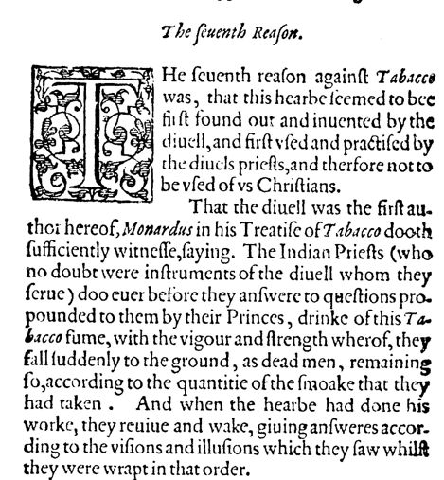
Figure 6: Detail from "The seuenth Reason," in Work for Chimny-Sweepers, Or, A Warning for Tabacconists Describing the Pernicious Vse of Tabacco, no Lesse Pleasant then Profitable for all Sorts to Reade, London, 1602.
As seen above, for the author “Philaretes,” one of the many reasons to denounce tobacco is due to its use in Native American religious practice. However, this same author expresses another major anxiety surrounding the mutability of tobacco. In “The eight and last Reason” he states:
But the like cannot be expected of the spirites rising of that kinde of melancholy which is engendred by the abuse of Tabacco. For this sort of melancholy humor is neither bright & shining like to molten gold, nor yet the grounds of pure and perfect blood, but rather an earthly and adust matter, not much vnlike stoncole or scorched earth. So that the spirites issuing from it must needs be of a diuers and farre contrarie qualitie and nature.

Following as it does from a list of the other methods in which tobacco enacts unwelcome change upon the body, this final warning reads like a severe mental health warning. On the one hand, the beating heart of the Galenic theories is this early modern anxiety surrounding change. A perfect body would comprise of perfectly balanced humors, therefore the same reasons that Monardes could suggest tobacco for balance apply to the basis for Philartes’ recommendation to avoid. On the other hand, there also existed a long history of alchemical philosophies underpinning the natural sciences. The principle theory underlying alchemy is a transubstantiation of sorts where base metals might be transformed into gold. However, as seen in this eighth reason, the metamorphosis of the self, or even one’s soul can also be seen to be changeable, perhaps even through the use of “Indian” tobacco.
Certainly, one poem in Sir John Beaumont’s (1583-1627) The Metamorphosis of Tabacco also published in 1602 confirms Philartes’ suspicions. In “To the white Reader” he writes, “Take vp these lines Tabacco-like vnto thy braine, / And that diuinely toucht, puff out the smoke againe.” The speaker exhorts the reader to metaphysically imbibe his words, to be changed as through exotic, divine touch of tobacco. As a discourse therefore, tobacco’s ability to spiritually transcend is acknowledged, promoted, and refuted. That said, anxieties about the nature of the divine in tobacco continued to function as an antagonist to the herb for many. The most famous detractor from the first years of the seventeenth century was James I/VI of England and Scotland (1566-1625). In his 1604 publication fantastically titled A counter-blaste to tobacco, he opposes the “vile custome,” and denies any of its purported medicinal properties. Claiming it soils the inside of one’s body with an “unctuous and oile kinde of soote,” his religious prejudices are laid bare in the warning that men are “piece by piece” allured.
Notwithstanding, growth of tobacco as a commodity fueled English colonization in America, and its popularity swelled the numbers of settlers landing on the shores of the eastern seaboard. By the time John Rolfe’s fledgling hybridized plants took root in the Chesapeake region, the Spanish had already created a European market for the commodity. However, as tobacco gained in popularity in English markets, so too did the potential for reaping profits grow in the minds of budding colonists. Paired with diverse other social drivers including enclosure, would-be tobacco profiteers streamed across the Atlantic in order to participate in the combustible boom that was the tobacco market. Yet, as tobacco’s consumption and popularity grew in Europe, so too did American acreage under English plows become cultivated. As Europeans scratched into that “virgin” earth, so too did their presence displace the people who were already there. I hesitate to dig deeper here; we already know the end of this story. However, an important question can be dredged up from this fait accompli of early English-Indian interaction, expansion, and ensuing conflict: Despite dubious medicinal understandings and its divisive addictive attributes, why did tobacco emerge as the leading agricultural commodity?
One potential answer may come from prescribed gender roles on both sides of the Atlantic. While most American agriculture was carried out by Indian women, it is likely that tobacco, considered a medicinal, was uniquely the prerogative of men. Most agricultural practices were indignantly snubbed by Native American males, a fact often repeated when observing social and cultural difference between European and Indigenous gender roles. That Native American men were likely participating in the cultivation of tobacco solely due to its medicinal status may be crucial to its subsequent uptake by the agricultural pursuits of Europeans males settling there, serving as a rare cultural alignment in that specific industry. Another reason suggestive for the captivating effects of tobacco on the European mind as a socially divided herb was that they (mistakenly) perceived it solely as a practice for the more learned or religious married men among the Powhatans. Tobacco was offered to visitors, whether or not their intentions were known. It was a way of propagating peace through holy smoke.
Indigenous American use of tobacco can be traced back archaeologically for millennia. In large part, tobacco’s function in the Americas in large part transcended recreational use, and as seen in Figure 2, the Mesoamerican Codex Borbonicus depicted tobacco as extant from the first moments of creation. Unsmoked tobacco served as a mechanism of blessing and protection. Though it might form part of celebratory feasts, it was also used as a grave good. It might function as a mutable physical boundary in the construction of sacred circles, or serve as a token or offering when embarking upon journeys. More often than not, however, tobacco would be offered to guests, both known and unknown, through a spiritual and ritualized formality which eventually would come to be called the calumet ceremony. Tobacco, when placed in a calumet, burned and offered freely, functioned as a conduit of peace and acceptance through the resultant holy smoke.
The origins of the calumet follow another empire in the early colonization of America: the French. According to the Oxford English Dictionary, “calumet, n.” is derived etymologically from the Norman French word, its tracery as far back as the Latin calamellus, a diminutive of calamus reed. As an object, a calumet, in general, comprised multiple constituent parts. These included a catlinite bowl in which to place the burning herb, and a long reed or stem that served to draw the smoke to one’s mouth. These pipes were highly decorated objects, and each adornment carried heavy symbolic significance to the Native Americans who possessed them. In 1699, André Pénicaut describes it as “a stick, or hollow cane, about one ell long, decorated all over with feathers of parrots, birds of prey, and eagles. All these feathers tied together around the stick look just about like several lady's fans from France joined together. At the end of this stick is a pipe which they call calumet.” However, as above the term calumet also encompasses the diplomatic ceremony in which the pipe was used to ritually imbibe the smoke. In his narrative of late seventeenth and early eighteenth century travel up and down the Mississippi, Pénicaut describes several recurrences of the calumet ceremony while he accompanied continual expeditions throughout French colonial America.
Though use of tobacco proliferated in the Americas even in the protohistorical period, the calumet as a “peace pipe” and the concomitant practice of the ceremony appears to have been spread through transcontinental riverine travel by the French. Ian Brown points to the temporal and geographical distributions of “elbow” catlinite bowls in protohistorical period archaeological evidence through the Southeast as a main convincing agent in his assessment. In understanding this complex picture of the spread of the diplomatic ritual and use of the calumet pipe, while Brown’s assertions may point to the proliferation of the pipe through Indian contact with the French, it is by no means certain that the practice stemmed from the French alone, or if it organically spread through Native contact in the same period.
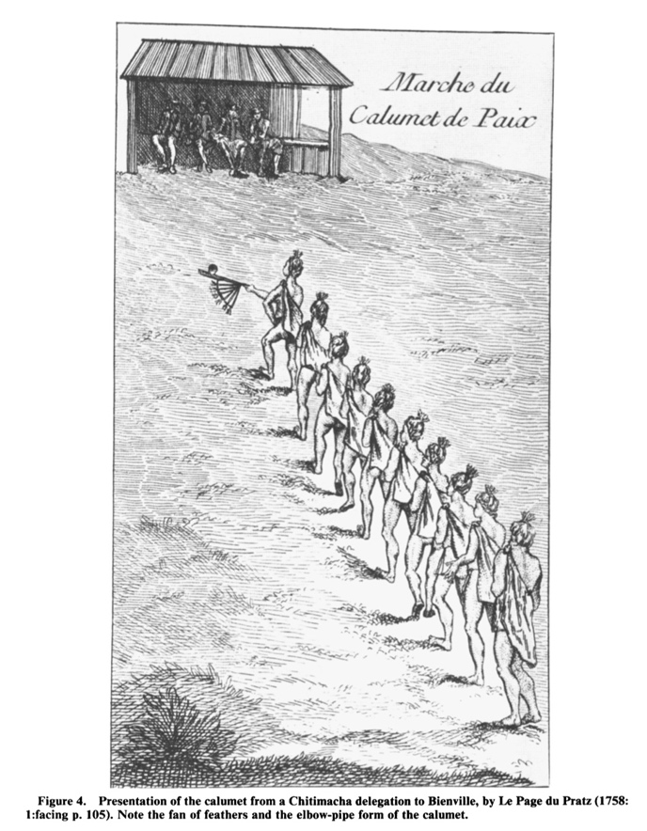
Figure 7: Marche du Calumet de Paix, 1758. Engraving by Antoine-Simon le Page du Pratz. From Brown, “The Calumet Ceremony in the Southeast as Observed Archaeologically.”
Outside of French colonial America, tobacco and the calumet proliferated. From the Tupinambá in Brazil to the Inuit who resided in the farthest northern territories unable to support cultivation, American Indians were able to obtain tobacco through trade and utilized it ritualized ceremony. As Steinmetz points out, “The Sacred Pipe was a sacramental that sanctified almost every life situation.” Its wide-ranging use may have derived from tobacco’s status as an entheogen. This term refers to plants [medicines] that are able to evoke a “god within.” Though few experience otherworldly congress with divinities during tobacco use today, Peter Mancall states that in the early modern period, “ingesting it could produce psychotropic effects, including hallucinations, that suggested users had access to forces beyond the visible world.” These aspects echo those many European anxieties and fears discussed above, that even recreational use of tobacco may also allow seepage of Indigenous religion into the European mind by vector of communication with a pagan, otherworldly spirit. It is somewhat miraculous, therefore, that in symbolically divorcing tobacco from its religious connotations, the commercial imperatives of European merchants, slavers, and medical professionals were able to culturally appropriate the entheogens in the alkaloidal effect of the nicotine, and still remove the fear that an exotic religion might infect their bodies, minds, and souls. Thus, tobacco was repackaged as a medicinal, safe commodity, one that overcame the original European entheogen stigma of being a “tool of the devil.”
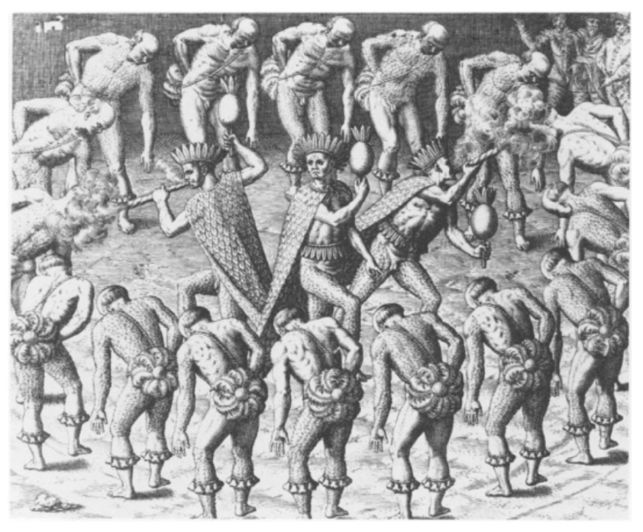
Figure 8: Engraving of the Tupinambá of Brazil using tobacco during a ritual dance, by Theodore de Bry, from Americae Tertia Pars, Frankfurt-am-Main, 1593. From Mancall, Nature and Culture, 77.
Indeed, tobacco, along with its companionate acerbic drink coffee, entered the European marketplace as a substance capable of a different kind of transcendence, as a commodified luxury item of an emerging vernacular culture. This culture looked to harness other aspects of tobacco. Outside of the medical propaganda extolling the herb’s virtues, it was also popularized “as a drug to be taken in small doses to focus the mind.” Stemming from the widespread practice of adult Indigenous men, engaged in rational political debate, especially as protected by the prophylactic effect of the “peace pipe,” it is interesting to note the similarities between these American groups, and their “enlightened” counterparts on the other side of the ocean.
When English venturers crossed the Atlantic they did anticipate gold, and lots of it, but as Mea Allen points out, “all the gold they ever found was the gold of the Virginian tobacco, though this was gold enough when translated into hard cash so easily.” In 1642, the Virginia legislature took that developing fungibility of the plant a step further and made it currency, only abandoning its use as a monetary “green” a few decades into the eighteenth century when markets proved too unstable. While Lennon may bemoan the “git” Sir Walter Ralegh, the explorer was neither the first nor the most preeminent route of introduction of the leaf into the sixteenth century transatlantic marketplace. However, as an explorer and founder of “Virginia,” his name for the lands of the Americas and especially the lands involved with English colonization, Ralegh’s name became interwoven with the popularization of the commodity.
Although his Nicotiana rustica, the North American cultivar of tobacco which he introduced in 1585 was not even sufficiently palatable for the English Market, the imported Nicotiana tabacum from the Spanish colonies that would stuff English pipes until John Rolfe created the hybrid plant from Trinidadian seeds. The association of a New World commodity of dubious use, Indian origin, and Spanish Catholic provenance would foment suspicion, providing oppositional discourse and dismay at its meteoric rise and widespread popularity, not to mention the observable physical and mental effects of the drug upon the human body. By 1617 his hybrid plant’s popularity had far outstripped its predecessor in popularity, enveloping the bourgeoning colonial and imperial marketplaces in clouds of smoke. It is this plant, tobacco, that became the cash crop of the seventeenth century English colonial enterprise, undergirding the colonization of English North America. Over the course of tobacco’s early modern trajectory, tobacco was a medicine, a commodity, and a sacred pathway to illumination.

BIBLIOGRAPHY

Allan, Mea, John Tradescant, and John Tradescant. The Tradescants: Their Plants, Gardens and Museum, 1570-1662. London: M. Joseph, 1964.

Bailyn, Bernard. The Barbarous Years: The Peopling of British North America: The Conflict of Civilizations, 1600-1675. New York: Alfred A. Knopf, 2012.

Beaumont, Sir John. The Metamorphosis of Tabacco. London: 1602. https://www.proquest.com/books/metamorphosis-tabacco/docview/2240932973/se-2.

Brown, Ian W. “The Calumet Ceremony in the Southeast as Observed Archaeologically,” chapter in Powhatan’s Mantle: Indians in the Colonial Southeast, Revised and Expanded Edition, eds. Gregory A. Waselkov, Peter H. Wood, and Tom Hatley, 371–420. University of Nebraska Press, 2006. https://doi.org/10.2307/j.ctt1djmhnk.18.

Burns, Eric. The Smoke of the Gods: A Social History of Tobacco. Temple University Press, 2007. http://www.jstor.org/stable/j.ctt14bt0m0.6.

Charleton, Anne. “Medicinal Uses of Tobacco in History.” Journal of the Royal Society of Medicine 97, no. 6 (June 2004): 292-6.

Columbus, Christopher. “Journal of the First Voyage of Columbus,” in Journal of Christopher Columbus (during his first voyage, 1492- 93), and Documents Relating to the Voyages of John Cabot and Gaspar Corte Real, edited and translated by Clements R. Markham. London: Hakluyt Society, 1893, https://web.as.uky.edu/history/faculty/myrup/his206/Columbus%20-%20Journal%20of%20the%20First%20Voyage.pdf.

Crosby, Alfred W. The Columbian Exchange: Biological and Cultural Consequences of 1492. Westport, Conn.: Greenwood Pub. Co, 1972.

Diamond, Jared M. Guns, Germs, and Steel: The Fates of Human Societies. New York: W.W. Norton & Co., 1997.

Everard, Giles. Panacea, Or, the Universal Medicine being a Discovery of the Wonderfull Vertues of Tobacco Taken in a Pipe : With its Operation and use both in Physick and Chyrurgery / by Dr Everard, &c [Panacea. Universal medicine.]. London: 1659. https://www.proquest.com/books/panacea-universal-medicine-being-discovery/docview/2240956881/se-2.

Fulton, Brian S. Drug Discovery for the Treatment of Addiction: Medicinal Chemistry Strategies. Hoboken: Wiley, 2014.

Gerard, John. The Herball Or Generall Historie of Plantes. Gathered by Iohn Gerarde of London Master in Chirurgerie very Much Enlarged and Amended by Thomas Iohnson Citizen and Apothecarye of London [Cruydenboeck. Cruydenboeck.]. London: 1633. https://www.proquest.com/books/herball-generall-historie-plantes-gathered-iohn/docview/2240902621/se-2.

Graeber, David, and D. Wengrow. The Dawn of Everything: A New History of Humanity. First American edition. New York: Farrar, Straus and Giroux, 2021.

Greene, Roland Arthur. Unrequited Conquests: Love and Empire in the Colonial Americas. Chicago: University of Chicago Press, 1999.

Hakluyt, Richard. The Principal Navigations, Voyages, Traffiques and Discoveries of the English Nation, Vol. XIII, America, Part II, ed. Edmund Goldsmid. Project Gutenberg, 2008. https://www.gutenberg.org/files/25645/25645-pdf.pdf.

Hatfield, Gary, “René Descartes”, The Stanford Encyclopedia of Philosophy (Summer 2018 Edition), Edward N/ Zalta (ed.), URL = https://plato.stanford.edu/archives/sum2018/entries/descartes/.

Knapp, Jeffrey. An Empire Nowhere: England, America, and Literature from Utopia to The Tempest. Berkeley: University of California Press, 1992.

Knapp, Jeffrey. “Elizabethan Tobacco.” Representations, no. 21 (1988): 26–66. https://doi.org/10.2307/2928376.

Lennon, John and Paul McCartney. “I’m So Tired.” On The Beatles, (or The White Album). London: EMI and Trident, 1968.

Mancall, Peter C. Nature and Culture in the Early Modern Atlantic. Philadelphia: University of Pennsylvania Press, 2017.

March, Jenny, and Neil Barrett. “PQ.” In Dictionary of Classical Mythology, 362–428. Oxbow Books, 2014. https://doi.org/10.2307/j.ctvh1djpk.19.

Monardes, Nicolás. Ioyfull Newes Out of the New-found Vvorlde Wherein are Declared, the Rare and Singuler Vertues of Diuers Herbs, Trees, Plants, Oyles & Stones, with their Applications, Aswell to the Vse of Phisicke, as of Chirurgery: Which being Well Applyed, Bring such Present Remedie for all Diseases, as may Seeme Altogether Incredible: Notwithstanding by Practice found Out to be True. also the Portrature of the Said Hearbs, Verie Aptly Described: Englished by Iohn Frampton Marchant. Newly Corrected as by Conference with the Olde Copies may Appeare. Whervnto are Added thrée Other Bookes Treating of the Bezaar Stone, the Herb Escuerconera, the Properties of Iron and stéele in Medicine, and the Benefit of Snow [Historia medicinal de las cosas que se traen de nuestras Indias Occidentales que sirven en medicina.]. London: 1596. https://www.proquest.com/books/ioyfull-newes-out-new-found-vvorlde-wherein-are/docview/2240925302/se-2.

Monardes, Nicolás. Primera Y Segunda Y Tercera Partes De La Historia Medicinal De Las Cosas Que Se Traen De Nuestras Indias Occidentales Que Sirven En Medicina: Tratado De La Piedra Bezaar, Y De La Yerva Escuerçonera. Dialogo De Las Grandezas Del Hierro, Y De Sus Virtudes Medicinales. Tratado De La Nieve Y Del Brever Frio ... Van En Esta Impression La Tercera Parte Y El Dialogo Del Hierro Nuevamente Hechos, Que No Han Sido Impressos Hasta Agora .. Sevilla: Alonso Escrivano, 1574.

Norton, Marcy. Sacred Gifts, Profane, Pleasures: A History of Tobacco and Chocolate in the Atlantic World. Ithaca: Cornell University Press, 2008.

Pénicaut, André, and Richebourg Gaillard McWilliams. Fleur De Lys and Calumet: Being the Pénicaut Narrative of French Adventure in Louisiana. Tuscaloosa, Ala.: University of Alabama Press, 1988.

Rountree, Helen C. The Powhatan Indians of Virginia: Their Traditional Culture. Norman: University of Oklahoma Press, 1989.

Sagard-Théodat, Gabriel. The Long Journey to the Country of the Hurons, tran. H. H. Langton, ed. George M. Wrong, Publications of the Champlain Society 25. Toronto: 1939.

Steinmetz, Paul B. The Sacred Pipe: An Archetypal Theology. Syracuse, N.Y.: Syracuse University Press, 1998.

Van Hee, Robrecht. “Dawn and Decline of the Holy Smoke.” Acta Chirurgica Belgica 108 (2008): 273-80.

Work for Chimny-Sweepers, Or, A Warning for Tabacconists Describing the Pernicious Vse of Tabacco, no Lesse Pleasant then Profitable for all Sorts to Reade [Warning for tabacconists.]. London: 1602. https://www.proquest.com/books/work-chimny-sweepers-warning-tabacconists/docview/2240919446/se-2.

John Lennon and Paul McCartney, “I’m So Tired,” on The Beatles, (or, The White Album), (London: EMI and Trident, 1968).
For the mythological belief of Prometheus giving fire, and thus knowledge to mankind, see e.g. “Prometheus,” in Dictionary of Classical Mythology, eds. Jenny March and Neil Barrett (Oxbow Books, 2014), 419–421. https://doi.org/10.2307/j.ctvh1djpk.19. For one example of early modern belief regarding speech/intellectual comprehension and utterance rendering mankind superior, see e.g Gary Hatfield, “René Descartes,” in The Stanford Encyclopedia of Philosophy, ed. Edward N. Zalta (Summer 2018 Edition). https://plato.stanford.edu/archives/sum2018/entries/descartes/.
For information about tobacco addiction and comorbidities, see Brian S. Fulton, Drug Discovery for the Treatment of Addiction: Medicinal Chemistry Strategies, (Hoboken: Wiley, 2014) 1.
Roland Arthur Greene, Unrequited Conquests: Love and Empire in the Colonial Americas (Chicago: University of Chicago Press, 1999), esp. 12-13.
For one early English warning of the dangers of tobacco smoking, see Work for Chimny-Sweepers, Or, A Warning for Tabacconists Describing the Pernicious Vse of Tabacco, no Lesse Pleasant then Profitable for all Sorts to Reade [Warning for tabacconists.] (London: 1602). https://www.proquest.com/books/work-chimny-sweepers-warning-tabacconists/docview/2240919446/se-2.
Christopher Columbus, “Journal of the First Voyage of Columbus,” in Journal of Christopher Columbus (during his first voyage, 1492- 93), and Documents Relating to the Voyages of John Cabot and Gaspar Corte Real, edited and translated by Clements R. Markham (London: Hakluyt Society, 1893), https://web.as.uky.edu/history/faculty/myrup/his206/Columbus%20-%20Journal%20of%20the%20First%20Voyage.pdf, 71.
Benjamin Breen, The Age of Intoxication: Origins of the Global Drug Trade, (Philadelphia: University of Pennsylvania Press, 2019) 9.
E.g. Alfred W. Crosby, The Columbian Exchange: Biological and Cultural Consequences of 1492, (Westport, Conn.: Greenwood Pub. Co, 1972).
E.g. Jared M. Diamond, Guns, Germs, and Steel: The Fates of Human Societies, (New York: W.W. Norton & Co., 1997).
Marcy Norton, Sacred Gifts, Profane, Pleasures: A History of Tobacco and Chocolate in the Atlantic World, (Ithaca: Cornell University Press, 2008), 4.
Richard Hakluyt, The Principal Navigations, Voyages, Traffiques and Discoveries of the English Nation, Vol. XIII, America, Part II, ed. Edmund Goldsmid (Project Gutenberg, 2008), https://www.gutenberg.org/files/25645/25645-pdf.pdf, 146-47. “There groweth also a certaine kind of herbe, whereof in Sommer they make great prouision for all the yeere, making great account of it, and onely men vse of it, and first they cause it to be dried in the Sunne, then weare it about their neckes wrapped in a little beasts skinne made like a little bagge, with a hollow peece of stone or wood like a pipe: then when they please they make pouder of it, and then put it in one of the ends of the said Cornet or pipe, and laying a cole of fire vpon it, at the other ende sucke so long, that they fill their bodies full of smoke, till that it commeth out of their mouth and nostrils, euen as out of the Tonnell of a chimney. They say that this doth keepe them warme and in health: they neuer goe without some of it about them.”
There are competing accounts of Rembert Dodoens’ depictions and descriptions of tobacco, vacillating between this nomenclature, and possibly a later amendment where it is named “Boerentabak.” A full investigation of herbal registers including Dodoens lies outside the purview of this essay, but see digital scholarship surrounding Dodoens at https://leesmaar.nl/cruijdeboeck/deel3/capitel089.htm, and also Robrecht Van Hee, “Dawn and Decline of the Holy Smoke,” Acta Chirurgica Belgica 108 (2008), 273-80.
Anne Charleton, “Medicinal Uses of Tobacco in History,” Journal of the Royal Society of Medicine 97, no. 6 (June 2004): 292-6.
Charleton, “Medicinal Uses of Tobacco in History,” 294. The ulcer on Nicot’s servant’s face may have been syphilitic, rather than cancerous – referred to as a “Noli-me-tangere.”
Nicolás Monardes, Primera Y Segunda Y Tercera Partes De La Historia Medicinal De Las Cosas Que Se Traen De Nuestras Indias Occidentales Que Sirven En Medicina: Tratado De La Piedra Bezaar, Y De La Yerva Escuerçonera. Dialogo De Las Grandezas Del Hierro, Y De Sus Virtudes Medicinales. Tratado De La Nieve Y Del Brever Frio ... Van En Esta Impression La Tercera Parte Y El Dialogo Del Hierro Nuevamente Hechos, Que No Han Sido Impressos Hasta Agora, (Sevilla: Alonso Escrivano, 1574). Also, Peter C. Mancall, Nature and Culture in the Early Modern Atlantic, (Philadelphia: University of Pennsylvania Press, 2017), 73.
Nicolás Monardes, Ioyfull Newes Out of the New-found Vvorlde Wherein are Declared, the Rare and Singuler Vertues of Diuers Herbs, Trees, Plants, Oyles & Stones, with their Applications, Aswell to the Vse of Phisicke, as of Chirurgery: Which being Well Applyed, Bring such Present Remedie for all Diseases, as may Seeme Altogether Incredible: Notwithstanding by Practice found Out to be True. also the Portrature of the Said Hearbs, Verie Aptly Described: Englished by Iohn Frampton Marchant. Newly Corrected as by Conference with the Olde Copies may Appeare. Whervnto are Added thrée Other Bookes Treating of the Bezaar Stone, the Herb Escuerconera, the Properties of Iron and stéele in Medicine, and the Benefit of Snow [Historia medicinal de las cosas que se traen de nuestras Indias Occidentales que sirven en medicina.] (London: 1596).
Monardes, Ioyfull Newes. Also Van Hee, “Dawn and Decline of the Holy Smoke,” 274.
Edmund Spenser, The Faerie Queene, 1590. Book 3, 5. 32 https://www.luminarium.org/renascence-editions/queene3.html,
Jeffrey Knapp, An Empire Nowhere: England, America, and Literature from Utopia to The Tempest (Berkeley: University of California Press, 1992), 136
John Gerard, The Herball Or Generall Historie of Plantes. Gathered by Iohn Gerarde of London Master in Chirurgerie very Much Enlarged and Amended by Thomas Iohnson Citizen and Apothecarye of London [Cruydenboeck. Cruydenboeck.], (London: 1633).
Gerard, The Herball, 358-361.
Giles Everard, Panacea, Or, the Universal Medicine being a Discovery of the Wonderfull Vertues of Tobacco Taken in a Pipe: With its Operation and use both in Physick and Chyrurgery / by Dr Everard, &c [Panacea. Universal medicine], (London: 1659), 29-30.
Idem, “Dedicatory.”
Everard, Panacea, “Dedicatory.”
Work for Chimny-Sweepers, title page.
Work for Chimny-Sweepers, 4.
“The eight and last Reason,” chapter in Work for Chimny-Sweepers.
“To the White Reader” in,Sir,John Beaumont, The Metamorphosis of Tabacco (London: 1602). https://www.proquest.com/books/metamorphosis-tabacco/docview/2240932973/se-2.
Rountree, The Powhatans of Virginia, 44. Though she states medicinal plants were gathered by men, she claims it was probably also women’s prerogative even though no early colonial English sources of the Powhatans say so specifically. She does later point to an ambiguous source that claims, “at Paspahegh ‘there was a Garden of Tobacco, and other fruits and herbes.’” Idem, 47.
Ian W. Brown, “The Calumet Ceremony in the Southeast as Observed Archaeologically” in Powhatan’s Mantle: Indians in the Colonial Southeast, Revised and Expanded Edition, edited by Gregory A. Waselkov, Peter H. Wood, and Tom Hatley (University of Nebraska Press, 2006), 314.
Mancall, Nature and Culture, 33; Norton, Sacred Gifts, Profane, Pleasures, 39.
Mancall, Nature and Culture, 31; Gabriel Sagard-Théodat, The Long Journey to the Country of the Hurons, tran. H. H. Langton, ed. George M. Wrong, Publications of the Champlain Society 25 (Toronto: 1939), 171.
Rountree, The Powhatans of Virginia, 108.
Idem., 113
Rountree, The Powhatans of Virginia, 137.
André Pénicaut and Richebourg Gaillard McWilliams, Fleur De Lys and Calumet: Being the Pénicaut Narrative of French Adventure in Louisiana (Tuscaloosa, Ala.: University of Alabama Press, 1988), 5.
Brown, “The Calumet Ceremony in the Southeast as Observed Archaeologically,” 311.
Mancall, Nature and Culture, 38-40.
Paul B Steinmetz. The Sacred Pipe: An Archetypal Theology (Syracuse, N.Y.: Syracuse University Press, 1998), 158.
Breen, The Age of Intoxication, 5-6.
Mancall, Nature and Culture, 33.
See e.g. “The eight and last Reason,” chapter in Work for Chimny-Sweepers.
Breen, The Age of Intoxication, 7.
Idem., 127.
Breen, The Age of Intoxication, 24.
David Graeber and D. Wengrow, The Dawn of Everything: A New History of Humanity, First American edition (New York: Farrar, Straus and Giroux, 2021), 473.
Ibidem.
Mea Allan, John Tradescant, and John Tradescant, The Tradescants: Their Plants, Gardens and Museum, 1570-1662, (London: M. Joseph, 1964), 64.
See e.g. BURNS, ERIC. “The Rise of Tobacco.” In The Smoke of the Gods: A Social History of Tobacco, 71–96. Temple University Press, 2007. http://www.jstor.org/stable/j.ctt14bt0m0.7.
Jeffrey Knapp, “Elizabethan Tobacco,” Representations, no. 21 (1988): 32.
Eric Burns, The Smoke of the Gods: A Social History of Tobacco, (Temple University Press, 2007). 61-2.
See e.g. Bernard Bailyn, The Barbarous Years: The Peopling of British North America: The Conflict of Civilizations, 1600-1675 (New York: Alfred A. Knopf, 2012), 79, 99.

